MINISTRY OF EDUCATION AND SCIENCE OF THE REPUBLIC OF KAZAKHSTAN

INTERNATIONAL INFORMATION TECHNOLOGY UNIVERSITY

COMPUTER ENGINEERING AND INFORMATION SECURITY DEPARTMENT

PROJECT

NoSQL Data Bases

Done by student Yersaiyn Yernar

Group CSSE1808DA

Almaty 2021

CONTENT

1. APPLICATION DESCRIPTION
2. Quality Function Deployment (QFD)
3. Use Case Diagram
4. Sequence Diagram
5. Class Diagram
6. The component diagram
7. DATABASE
8. APPLICATION DESCRIPTION

Doc Type: Requirements Description

System: Game shop

Revision: V.0_0

Revision Date: 01.04.2021

Requested by: Yernar Yersaiyn

Game shop is a web-application that enables the user to order and buy games with delivery online. Application in the user’s device will communicate with the server-computer. Application in one device could be used by only one customer. A customer will be open the app in his device. The customer will then be able to choose games or other goods on the list using search and add this good to basket. After choosing product, the user will be able to choose payment method:

1. Cash payment.

2. Cashless payment

Then, customer must be input address and phone-number in a special field in application.

The application will communicate with the server to find out if the product is in stock. If some kind of good are not in stock, the application displays on monitor of device this problem.

Besides, call-manager of pharmacy will get notification in the app after order. After call of manager to customer and getting confirmation by user about order, the application will send notification to courier. Courier will see address and phone number of customer to deliver product.

1. Quality Function Deployment (QFD)

|  |  |  |  |  |  |
| --- | --- | --- | --- | --- | --- |
| № | Requirements of customers | Points | 1 level | 2 level | 3 level |
| 1 | Importance | 10 | 10 | 9 | 8 |
| 2 | Precision | 10 | 10 | 8 | 6 |
| 3 | Quality | 10 | 10 | 10 | 9 |

1. Use Case Diagram

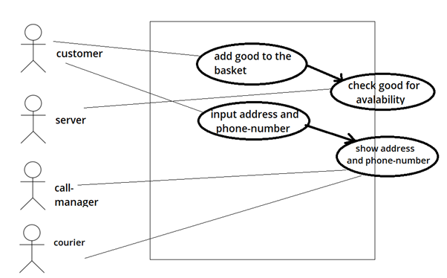

1. Sequence Diagram

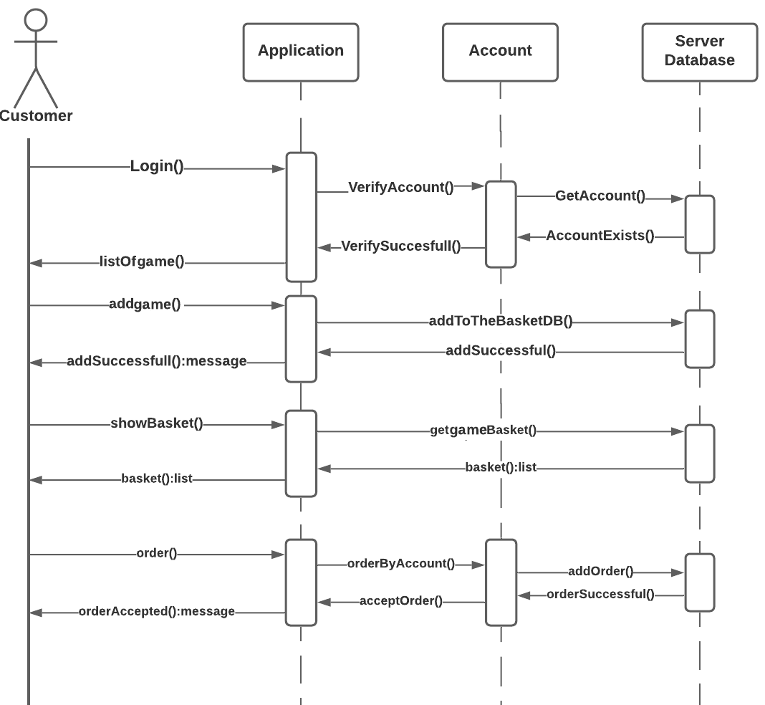

1. Class Diagram

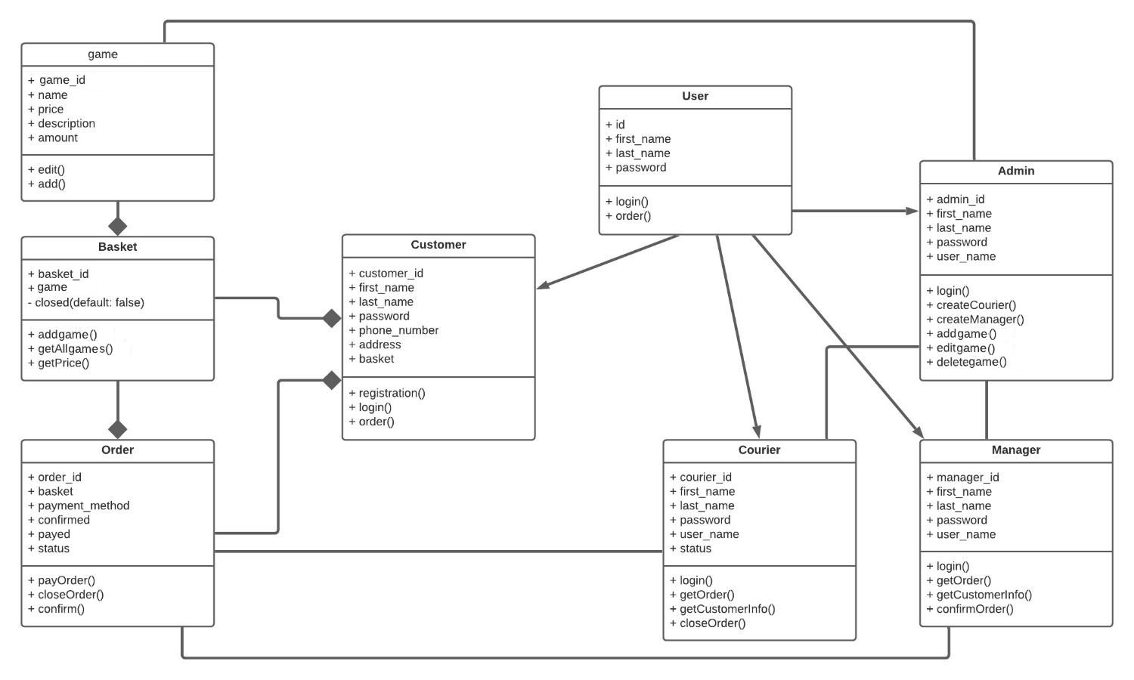

1. The component diagram

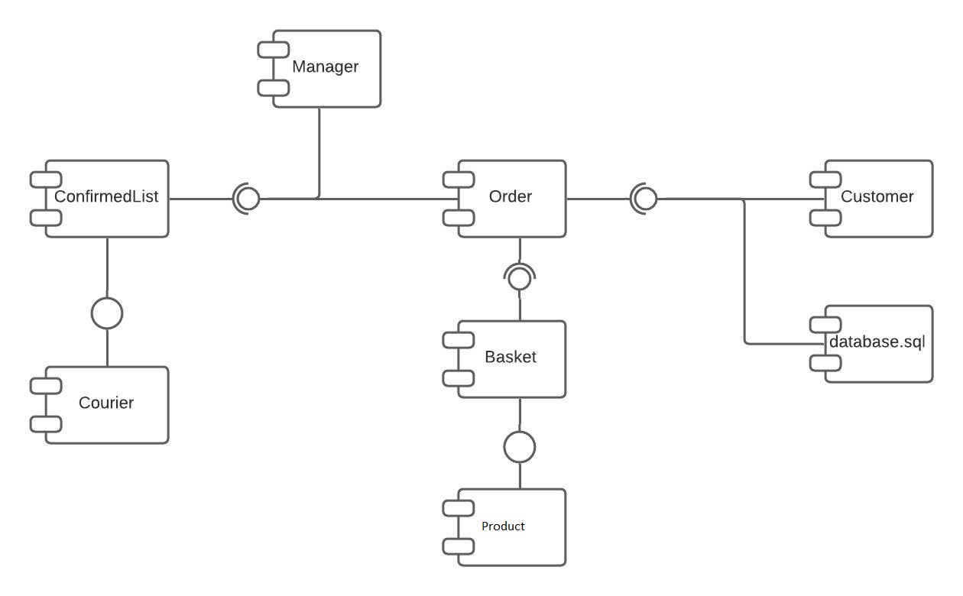

1. DATABASE

Database stores info about books and information about it.

Database type: MongoDb (NoSQL)

For it I will use Atlas and Compass (as lector showed in lectures)